N303: Lecture Project

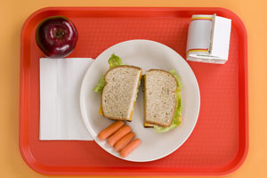

By: Katie Woff, Megan McMullen, Jenny LeGrand and Diana Becker

PART 1: SUMMARY OF OPERATIONS
Our goal is to maximize the nutritional value in school lunches and minimize costs through a strategically designed conventional foodservice system. We will strictly comply with the dietary guidelines set by the USDA for the National School Lunch Program and will enforce HACCP through every step of the procurement and production process to guarantee optimal safety, sanitation and health.

Procurement:
- Products will be obtained through the just-in-time method with deliveries taking place every Monday morning prior to school starting at 8:00 AM. First we will identify the product need based on our current inventory before making orders.
- Upon receiving products based on a weekly basis, the food service manager on site will check the invoice in comparison to the purchase order. This also includes checking for damage not only quantity of products. One this is done, all food will be labeled with name and delivery date and stored using FIFO (First In First Out).
- When storing incoming products, all food and paper supplies will be stored 6-8 inches above the ground and immediate storage of items requiring refrigeration or freezing in compliance with HACCP.

Production:
The objective of food production is to prepare the quantity of menu items needed while ensuring the desired quality is met, at an appropriate cost (Gregiore 165). The utilization of standardized recipes will make certain that this goal will be prepared and served on premises. This centralized production allows the food to be served immediately after it is made, while maintaining the quality and safety of all the menu items. Through attendance may vary, production needs to account for approximately 600 students per day (http://nces.ed.gov). The food service employers will work about 40 hours per week in the kitchen, preparing and storing the food and cleaning the facility. A daily storage and cleaning log will be filled out throughout the day. Staff members will come Monday through Friday, before school starts at 8 AM to prepare the food. They will then continue to work during and after the lunch period till the early evening.

Part II: THE MENU PLAN
In our generation, it’s harder than very to promote healthy eating among our youth while slipping in health foods and providing fun and familiar foods, especially in the school setting. We selected our meals in a way so that the meals would not shy the students away from eating them, and furthermore appeal to their preferences while providing adequate nutrients. Specifically, pizza, French fries, chocolate milk, tator-tots, and chicken nuggets were the top five food preferences from a study done in an Ohio school district, but foods that ranked in the “Top 20” included chocolate milk, strawberries, watermelon, sub sandwiches, white milk, grapes, yogurt and string cheese (Caine-Bish, Natalie & Barbara Schedule). We applied this specific finding in planning our foodservice system in order to improve the diets of the school children while further promoting life-long healthy eating habits.

MENU TYPE/OUTPUT VOLUME:

Menu Type/Pattern:
Our menu will be a non-selective, lunch only menu that will follow USDA guidelines for the USDA’s National School Lunch Program requirements http://www.fns.usda.gov/
- No more than 30% of calories come from fat
- Less than 10% from
- Provide 1/3 of recommended dietary allowances of protein, vitamin A, vitamin C, iron, calcium and calories
- Specifically our menu will follow a traditional pattern which bases menus on the minimum component quantities of the following: (http://dpi.state.nd.us)
- Meat/meat alternatives (poultry, lean meat, fish, cheese, eggs, cooked/dry beans, nuts, yogurt, etc.) (must be served in main dish) – 2oz/meal
- Vegetables/fruits (juice cannot make up more than half) – ¾ cup/meal
- Grains and breads (must\ be enriched or whole grain) – 1 serving/meal, 8 serving/week
- Milk (variety should be offered) – 8 fl. oz./meal
- Menu will be a 2 week cycle menu

Output Volume:
- Approximately 600 students enrolled in grades K-5
- On average school day, ~20% of students will either bring a lunch from home/ not attend
- On average school day, ~80% of students will utilize school lunch program
- Approximately 500 meals will be prepared each day

FACILITY SPACE AND EQUIPMENT
To ensure that lunches will be made properly and in a timely manner there will be plenty of space in the kitchen and efficient equipment will be provided for the lunch staff in a facility with 2,800 sq. ft. of space. See equipment in appendix B.

NUTRITION GOALS:
According to the USDA, national school lunch programs must meet the set requirements established by the Dietary Guidelines for Americans. These guidelines state that no more than 30% of calories may come from fat and less than 10% CAN COME FROM SATURATED FATE. In addition, the guidelines highlight specific nutrients including; protein, Vitamin A, vitamin C, iron, calcium and calories that the lunches must provide to give the children at least 1/3 of the recommended allowance for each (http://fns.usda.gov):
- Protein: 30g/day (1/3 = 9.99g)
- Vitamin A: 2,900 IU/day (1/3 = 966.66iu)
- Vitamin C: 42.5 mg/day (1/3 = 14.16mg)
- Iron: 10 mg/day (1/3 =3.33mg)
- Calcium: 800 mg/day (1/3 = 266.66mg)
- Calories (kcal): 2,100 kcal/day
*note – values obtained by averaging RDA’s for children ages 4-6 and 7-10 to give best overall recommendation for all children in the school lunch program from (http://ivy_league0.tripod.com/).
- Our overall nutritional goal is to meet at least the minimum requirement for each nutrient and comply with the fat guidelines set by the USDA.
- We also want to specifically make sure children are getting enough calcium and iron from their lunches. According to information collected by the USDA almost half of the children do not get enough calcium and up to a third do not get enough iron which could lead to increased risk of breaking bones and anemia respectively (http://health.kaboose.com/).
- Additionally we aim to provide a variety of different foods that help meet the nutrient requirements for the maximum enjoyment for the children.
- We also will portion meals into sizes that are appropriate for young children.

BUDGETARY GOAL:
In the year 2010 the National Student Lunch Program reported that of the 31.8 million participants, 17.6 million students qualified for free lunches, 3 million for discounted lunches and 11.2 million for full price. These statistics highlight the fact that 55% of participants qualify for free lunches due to their total family income, which is an extremely high percentage. Part of our goal is to minimize costs of school lunches so all students can afford to eat a healthy, satisfying meal despite economic distress, which is why our budgetary goal is to keep each meal under $3 per student (http://www.fns.usda.gov/).
The USDA provides support to the National School Lunch Program in schools predominately through cash reimbursements for each meal that is served. The guidelines for this are as follows:
- Free lunches get reimbursed $2.72
- Reduced lunches get reimbursed $2.32
- Paid lunches get reimbursed $0.26
Lunch prices at our elementary school are as follows:
- Paid- $3.00
- Reduced- $0.40
- Free- $0.00
According to the most recent Statistics from the National School Lunch Program 55% of students qualify for free lunches, 9% for reduced lunches and 35% must pay for their meals meaning:
- $275 students get free meals
  - $0 (meal price) + $748 (gov) = $748

- 45 students get reduced meals
  - $18 (meal price) + $104.40 (gov) = $122.40
- 175 students must pay for meals
  - $525 (meal price) + 45.50 (gov) = $570.50
- The average revenue for paid lunches and government reimbursement daily is = $1449.9/day
- There are about 180 days in a year of elementary school, so for the whole year the average revenue for paid lunches and government reimbursement is = $259,362/year
In conclusion we have met our budgetary goal of $3.00 or less per meal per student by providing paid lunch costs of $3.00, reduced costs of $0.40 and free lunches for $0.00 all while generating impressive daily and yearly revenues. See Appendix C for item cost breakdown.

PART III: FOOD SAFETY PROGRAMMING:
One of the potential operational risks is food borne illness. Although not extremely common, recent testimony from the U.S. General Accounting Office (2002) reported that school-related foodborne illness outbreaks have increased about 10% annually through the 1990s. To avoid such an outbreak, optimal sanitation and food-handling practices will be installed. A decrease in food quality (nutritional, aesthetic or microbial) is also a potential risk. Several studies of food-handling practices in school foodservice indicate that there are areas of concern that need to be addressed (Blakeslee & Pinner, 1999; FDA, 2000; Giampaoli, Cluskey & Sneed, 2002; Gilmore, Brown & Dana, 1998; Henroid & Sneed, in press; Kim & Shanklin, 1999), thus excellent food-handling techniques must be implemented by the school foodservice employees to avoid this as well. This risk of decreased food quality can also be avoided with a proper inspection system before food reaches the kitchen upon delivery and proper training of foodservice managers.
The methods that are employed to monitor, correct and verify the HACCP program are as follows:
- Equipment is installed properly and equipment maintenance schedules are in place and documented.
- Written procedures for cleaning and sanitizing equipment and facility are in place and documented, and followed by all faculty members. A master cleaning and sanitation schedule will also be in place.
- Written policy and procedures for personal hygiene for employees and all visitors are in place and documented, and are followed by every person who enters the production or service area.
- An orientation program on food safety for new employees is in place and documented, as well as an ongoing training program on food safety & HACCP.
- All chemicals are separated from food products, and written procedures to ensure separation of chemicals from foods are in place.
- All products are stored under sanitary conditions and in the areas with appropriate temperature and humidity.
- All food products are dated when put into storage
- A pest control program and documentation thereof is in place.
- Food temperatures are maintained and monitored. Time potentially hazardous food spends in the temperature danger zone is monitored.

References
- Almazan, Barbara A., and Jeannie Sneed. “Food Safety and HACCP in Schools”. The Journal of child Nutrition and Management 1 (2003). The Journal of Child Nutrition and Management- School Nutrition Association. Web. 25 April 2011.
- Caine-Bish, and Barbara Schedule. “Food Preferences of School Aage Children and Adolescents in an Ohio School District. “The Journal of Childd Nutrition and Management 2 (2007). Journal of Child Nutrition & Management- School Nutrition Assocation. School Nutrition Association. Web. 25 April 2001
- Gregoire, Mary B., Food Service Organizations: A Managerial and Systems Approach. 7th ed. Boston. Prentice Hall, 2010.
- National School Lunch Annual Statistics.” USDA- Food and Nutrition Service. Web. 20 April 2011. (http://www.fns.usda.gov/pd/slsummar.htm).
- “National School Lunch Program“. National School Lunch Program. USDA-Food and Nutrition Service. Web. 20 April 2011. (http://www.fns.usda.gov/cnd/lunch/aboutlunch/nslpfactsheet.pdf).
- Nutrition Analysis Tool 2.0”. NAT Tools for Good Health. Web. 16 April 2011. (http://www.myfoodrecord.com/mainnat.html).
- “Pasta Cookers I Katom Restaurant Supply.” Web. 30 April 2011. (http://restaurant-supplies.katom.com/cat/pasta-cookers.html).
- Restaurant Equipment, Restaurant Supplies-Central Restaurant Supply. Central Restaurant Products. Web. 30 April 2011. (http://www.centralrestaurant.com/?cid=WSPCGOCBRCR153&gclid=CI-skfaGrbUCFQThQgod1QgADA).
- Sneed, Jeannie, and Sukyung Youn. “Training and Perceiaved Barriers to Implementating Food Safety Practices in School Foodservice”. Journal of Child Nutrition and Management 2 (2002). Journal of Child Nutrition & Managemetn- School Nutrition Association. Web. 26 April 2011.
- “Table 5. – Beverage Public School Size (mean Number of Students per School), by Instructional Level and by State: Overview of Public Elementary and Secondary Schools and Districts: School Year 1999-2000.” National Center for Education Statistics (NCES) Home Page, a Part of the U.S. Department of Education. Web. 21 April 2011. (http://nces.ed.gov/pubs2001/overview/table05.asp).
- “Traditional School Lunch Pattern”. USDA National School Lunch Program. Web. 20 April 2011. (http://www.dpi.state.nd.us/child/snp/nslp/).
- “USDA Recipes for Schools.” USDA Recipies for Schools. USDA- Food and Nutrition Service. Web. 20 April 2011. (http://teamnutrition.usda.gov/Resources/usda_recipes.html).
- A ”Vitamins RDA” Tripod.com. Web 20 April 2011 (http://ivy_league0.tripod.com/rhyme_of_the_ancient_wanderer/id82.html).
- “10 Essential Vitamins and Minerals Kids Often Miss” Kaboose. Web 21 April 2011 (http://health.kaboose.com/nutrition/vitamins-and-minerals-kids-miss.html).
APPENDIX A
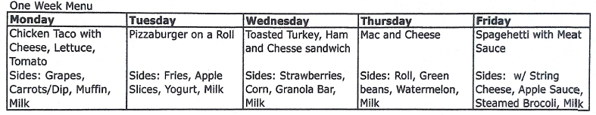

APPENDIX B
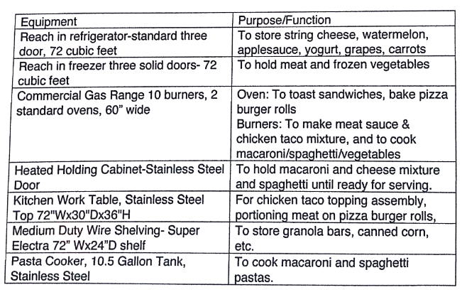

APPENDIX C:
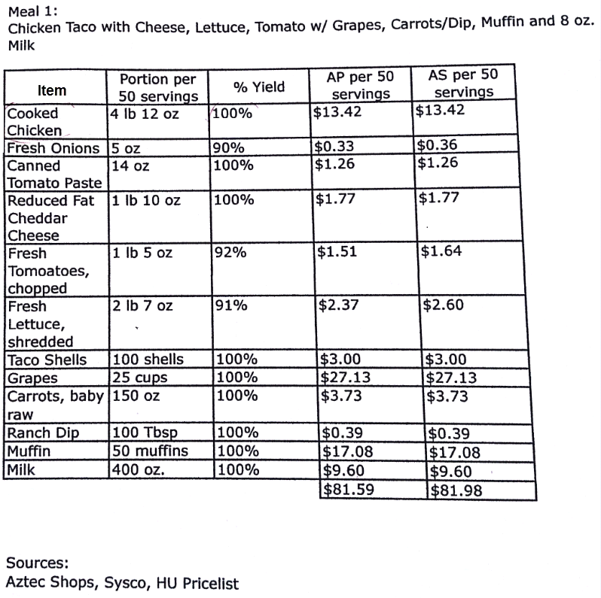

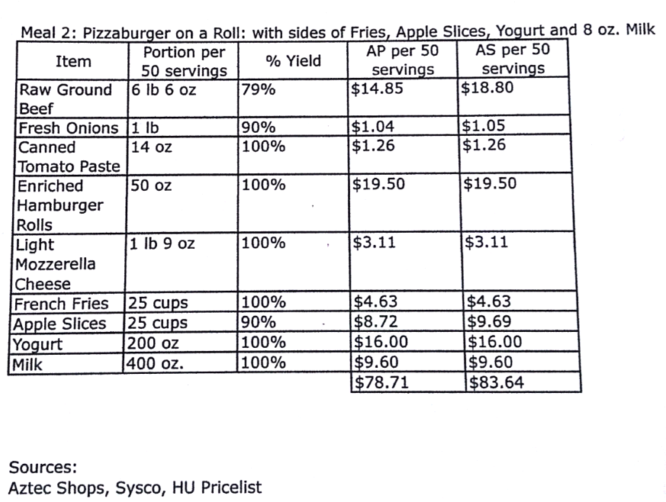

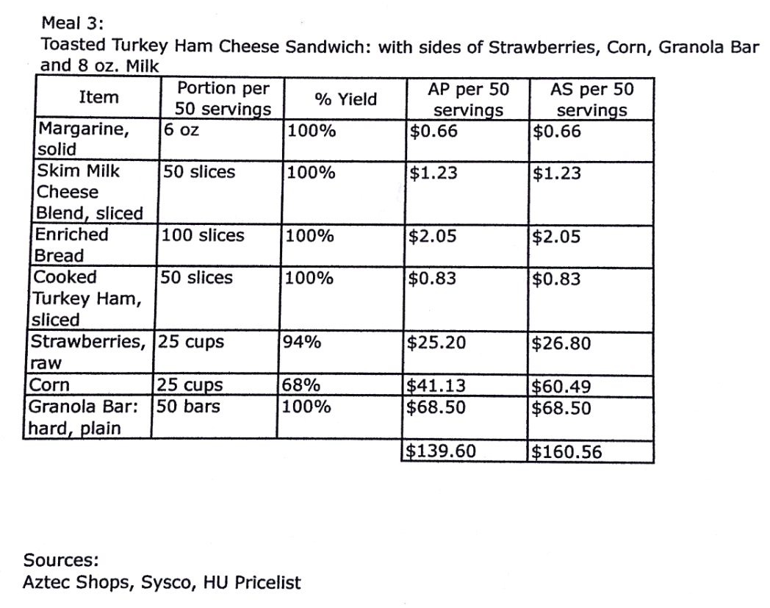

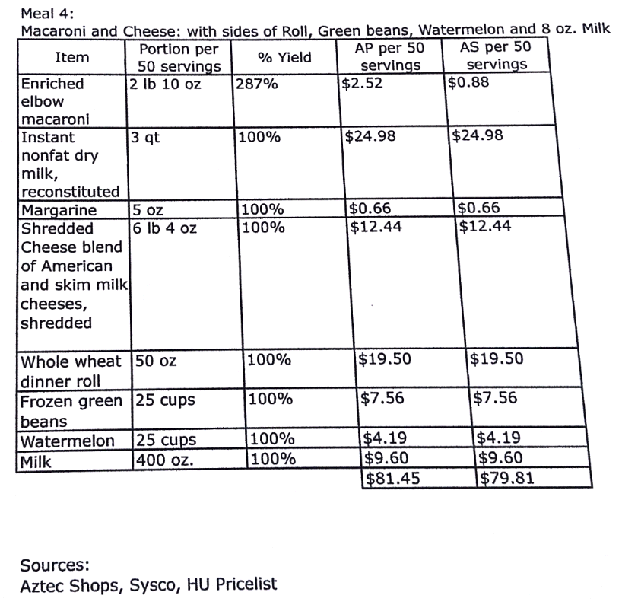

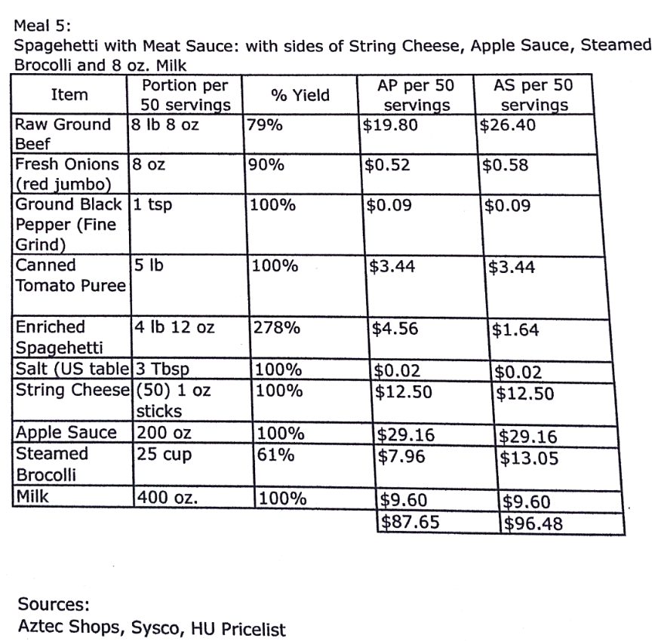

APPENDIX D
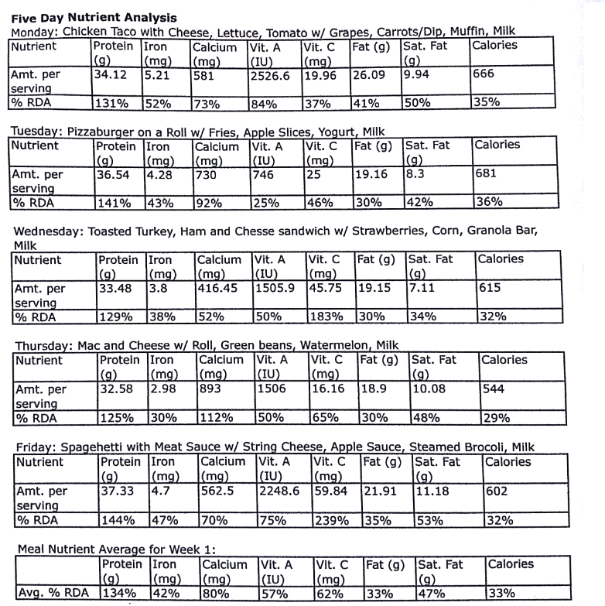

APPENDIX E
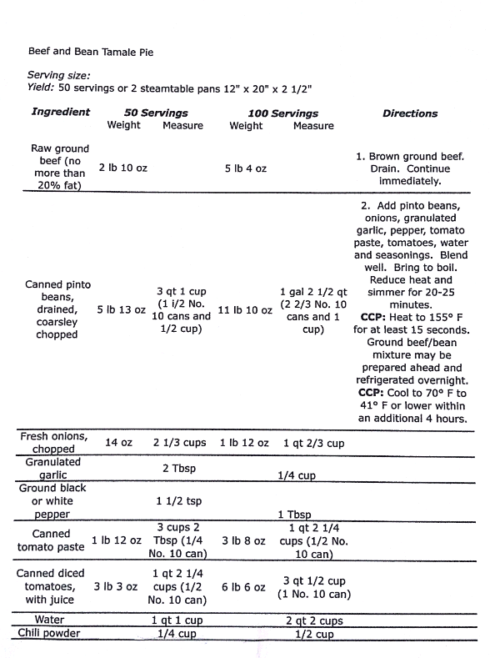
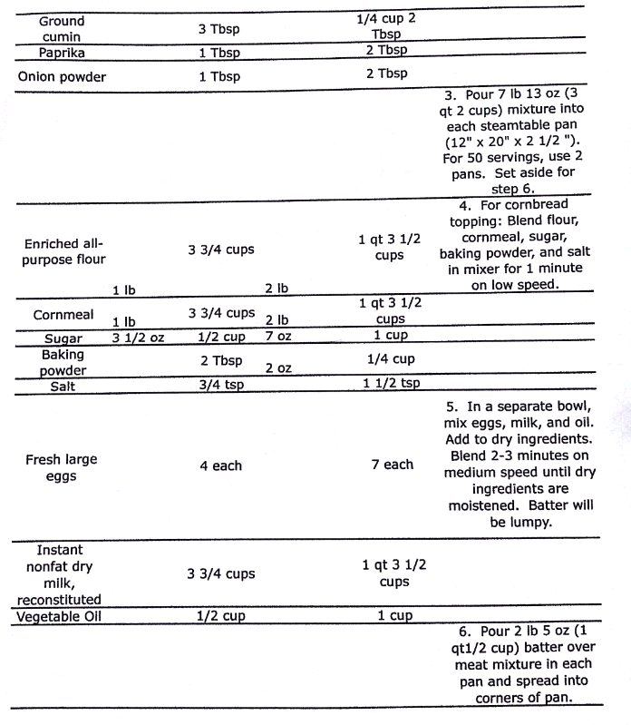

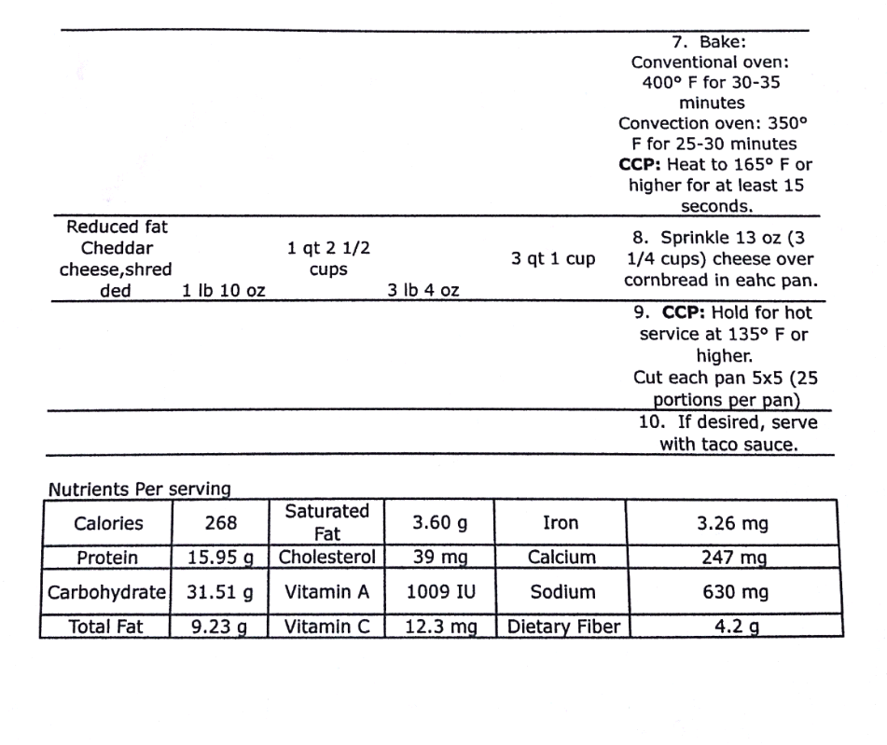
APPENDIX F